Exercise 1:

X | Y | AND | OR | XOR | NOT | NAND | NOR | XNOR
0 | 0 | 0 | 0 | 0 | 1 | 1 | 1 | 1
0 | 1 | 0 | 1 | 1 | 1 | 1 | 0 | 0
1 | 0 | 0 | 1 | 1 | 0 | 1 | 0 | 0
1 | 1 | 1 | 1 | 0 | 0 | 0 | 0 | 1

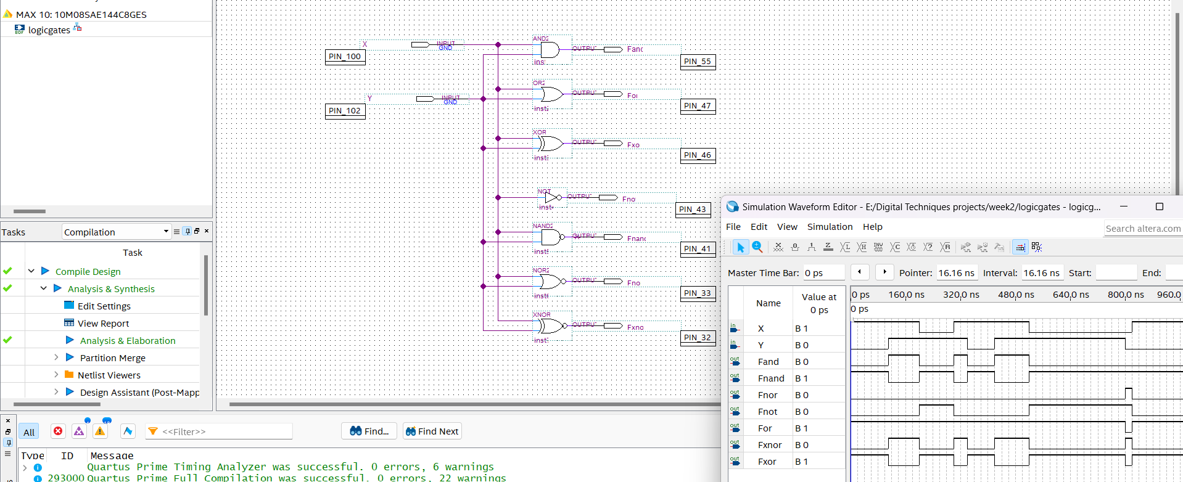

Exercise2:
x | y | z | Out2 | Out1 | dec
0 | 0 | 0 | 0 | 0 | 0
0 | 0 | 1 | 0 | 1 | 1
0 | 1 | 0 | 0 | 1 | 1
0 | 1 | 1 | 1 | 0 | 2
1 | 0 | 0 | 0 | 1 | 1
1 | 0 | 1 | 1 | 0 | 2
1 | 1 | 0 | 1 | 0 | 2
1 | 1 | 1 | 1 | 1 | 3

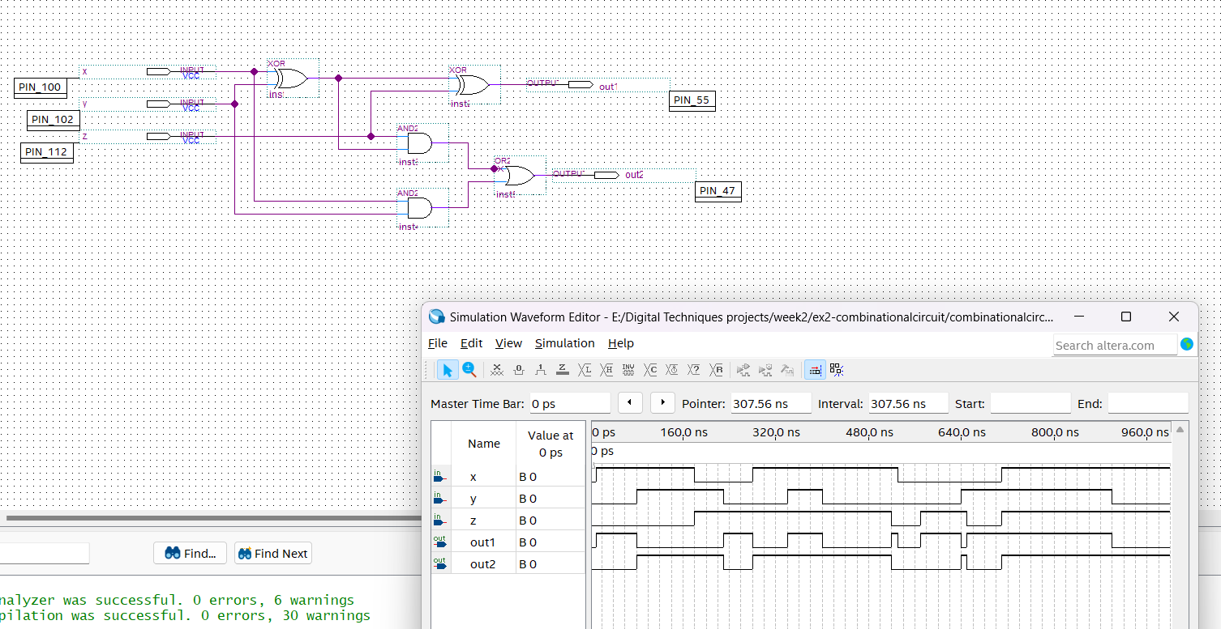

The circuit shows that if 1 of the 3 inputs is true, then output1 will be activated. If 2 of them are true, then output2 will be activated. Also, if all of the 3 inputs are true, then output1 and output2 will be activated.

